SOAP

* Simple Object Access Protocol
* Developed by Microsoft
* Allow to invoke services in XML
* Provides instructions for the how the message is bound in the underlying protocol (HTTP in this lesson)

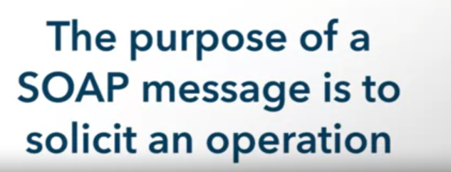

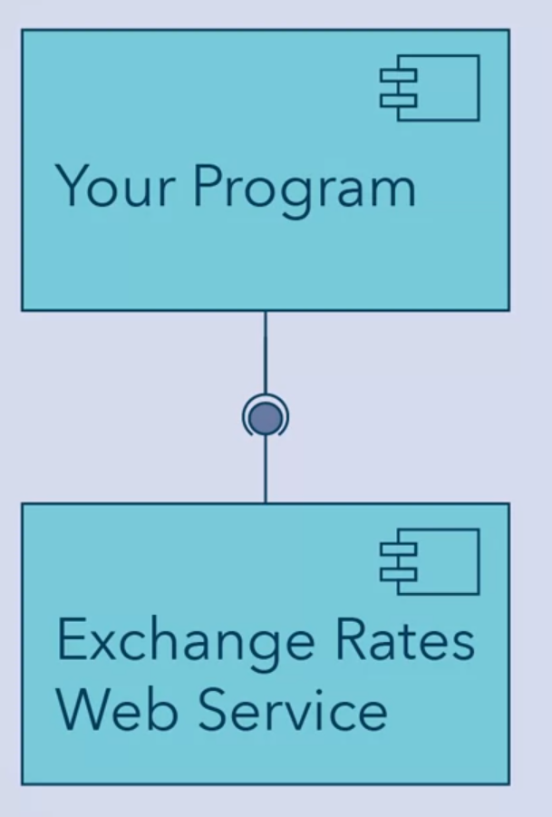

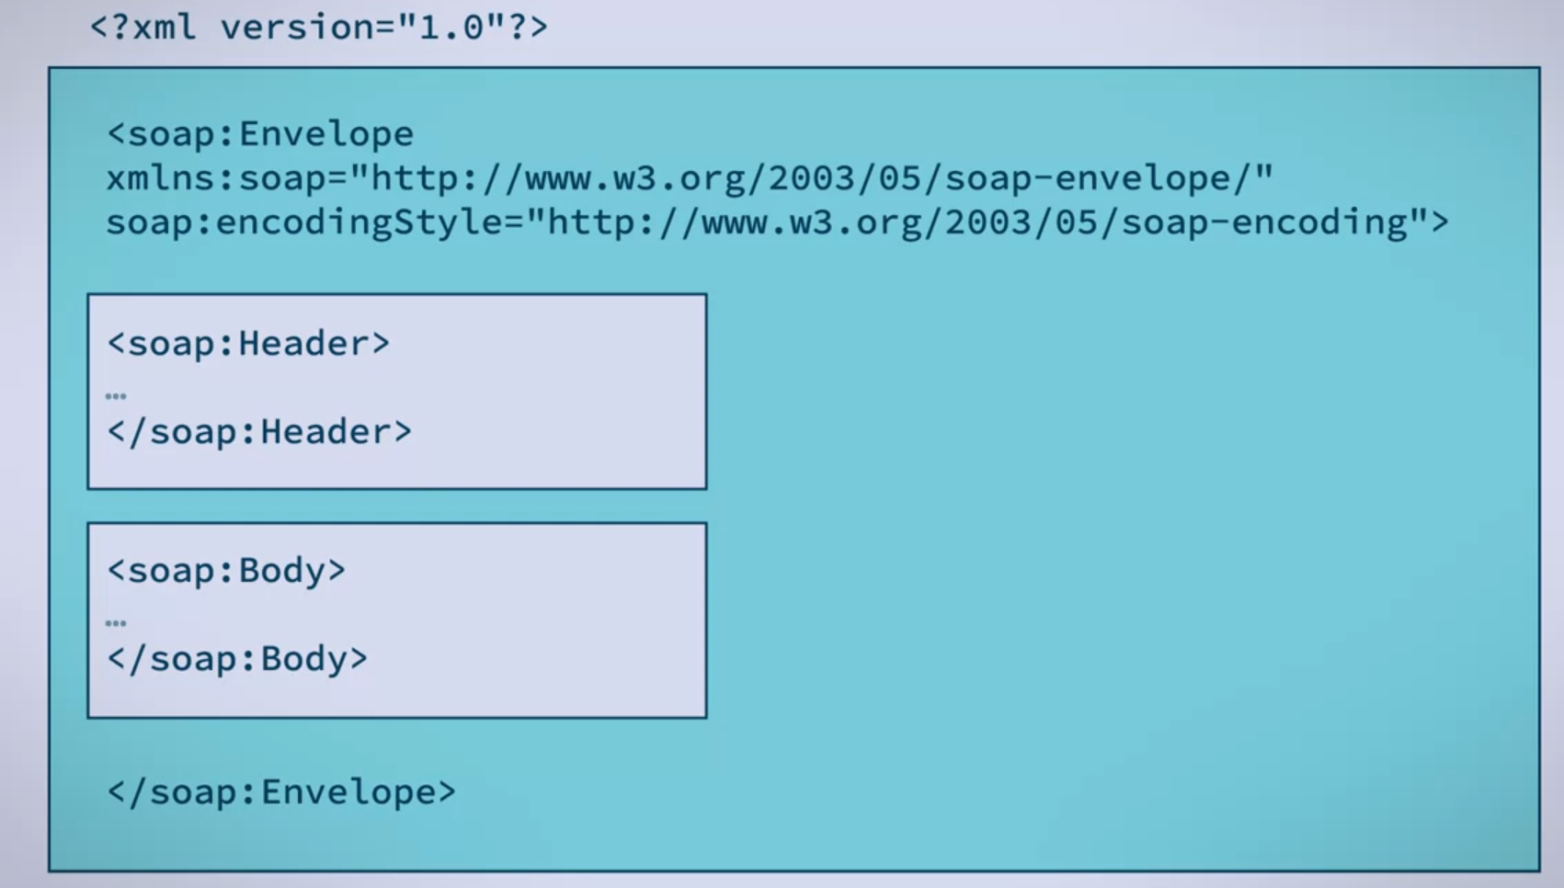

2 styles of SOAP Messaging

* Document
* RPC

Document Style SOAP

* Like a document of a company’s purchase order
* Structured

The type of form sent tells the service what to do, and fields in the form are how parameters are passed.

RPC Style

* Remote procedure call style looks like a method call, where you invoke a process and pass parameters. They're not quite like a simple method call in OO, though, since they need lots of extra information like the transport protocol.

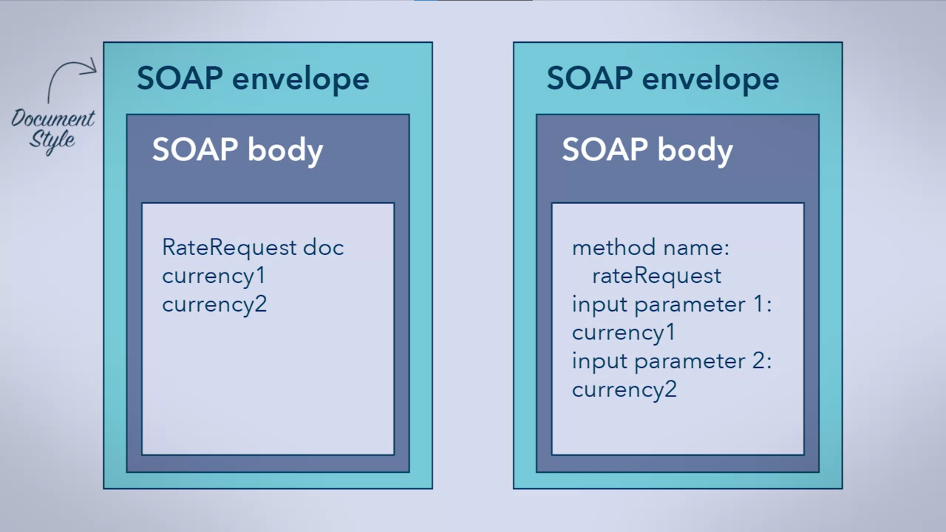

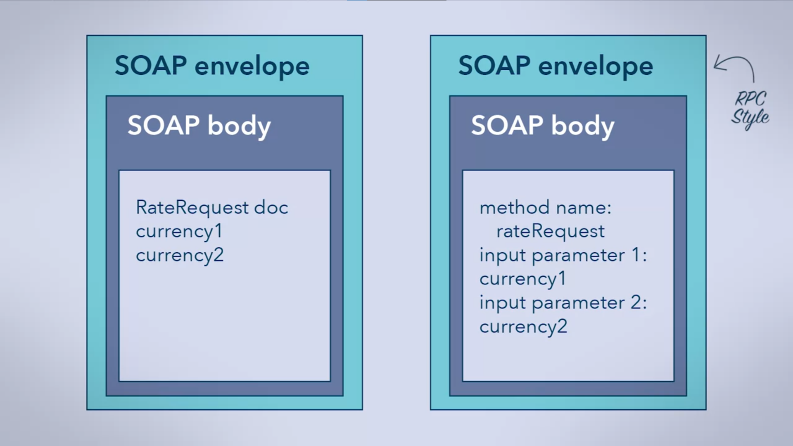

* Sent by some TP (Transfer Protocol
  + SMTP – used by emails
  + HTTP – common, this is what we’ll focus on

HTTP POST

* To send and the HTTP will determine where to send it since it is not included in the request

Simple interaction in SOAP

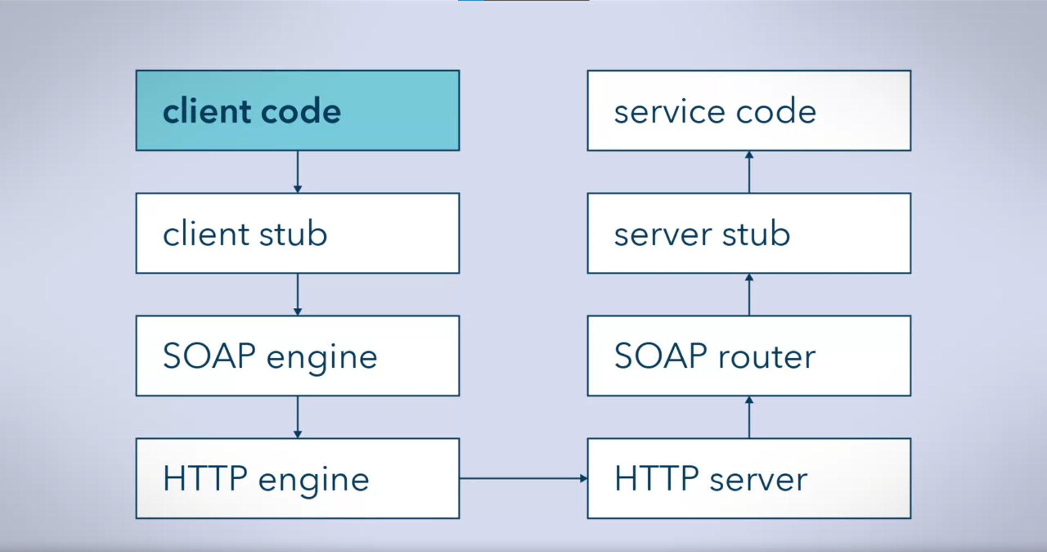

4 Basic Messaging Patterns

1. Request-Response

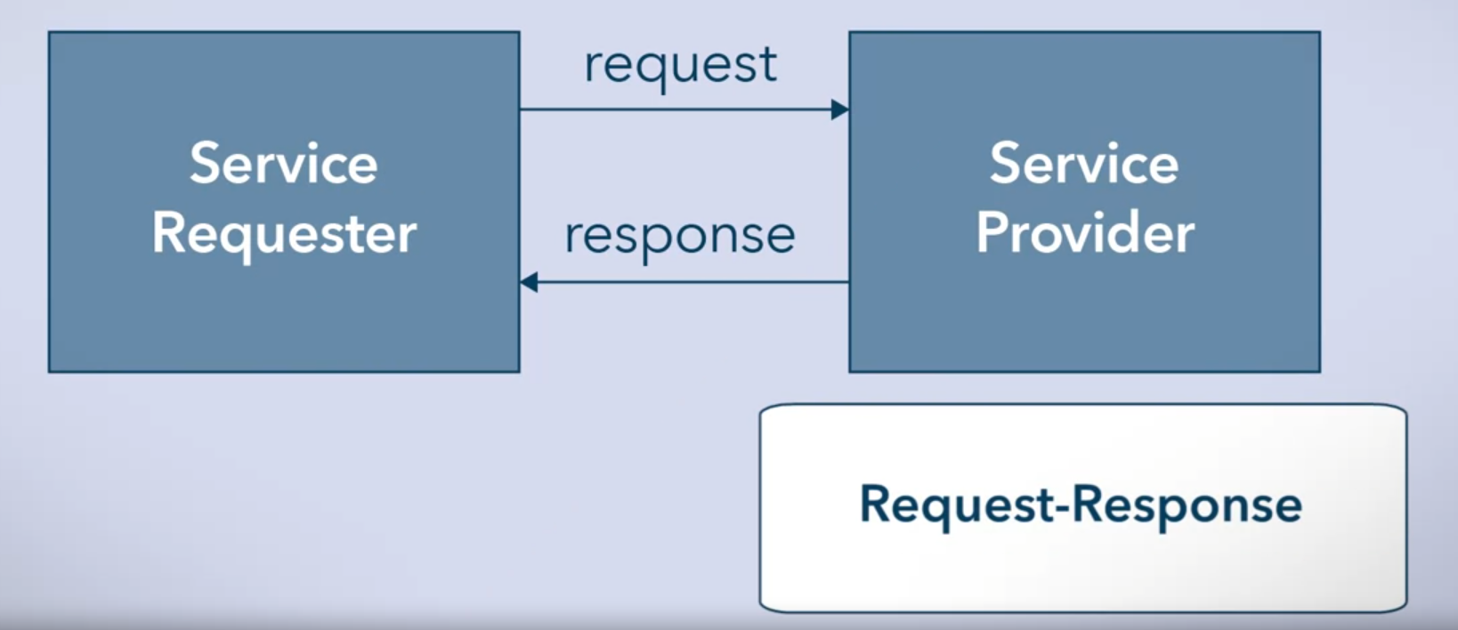

* + synchronous

1. Solicit-Response

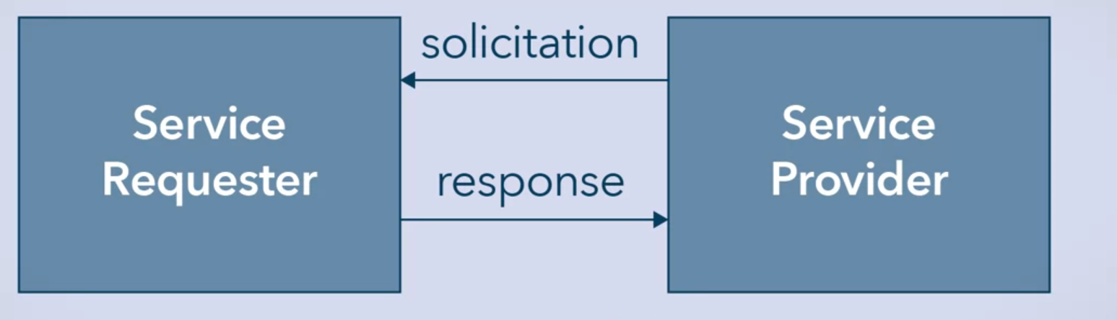

* + Synchronous
  + Often a confirmation

1. One-way

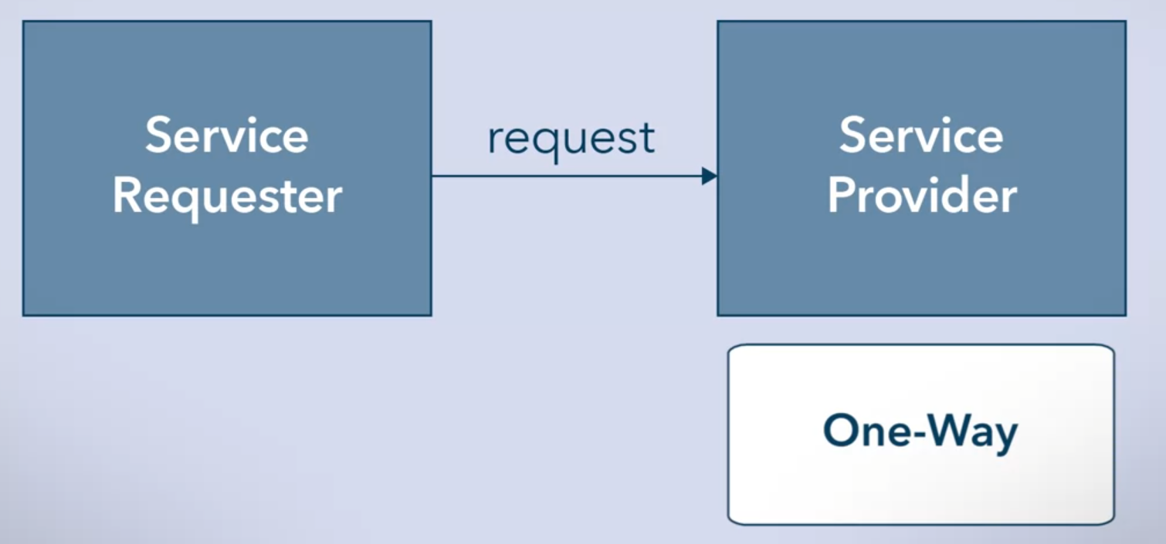

* + No response expected
  + Asynchronous

1. Notification

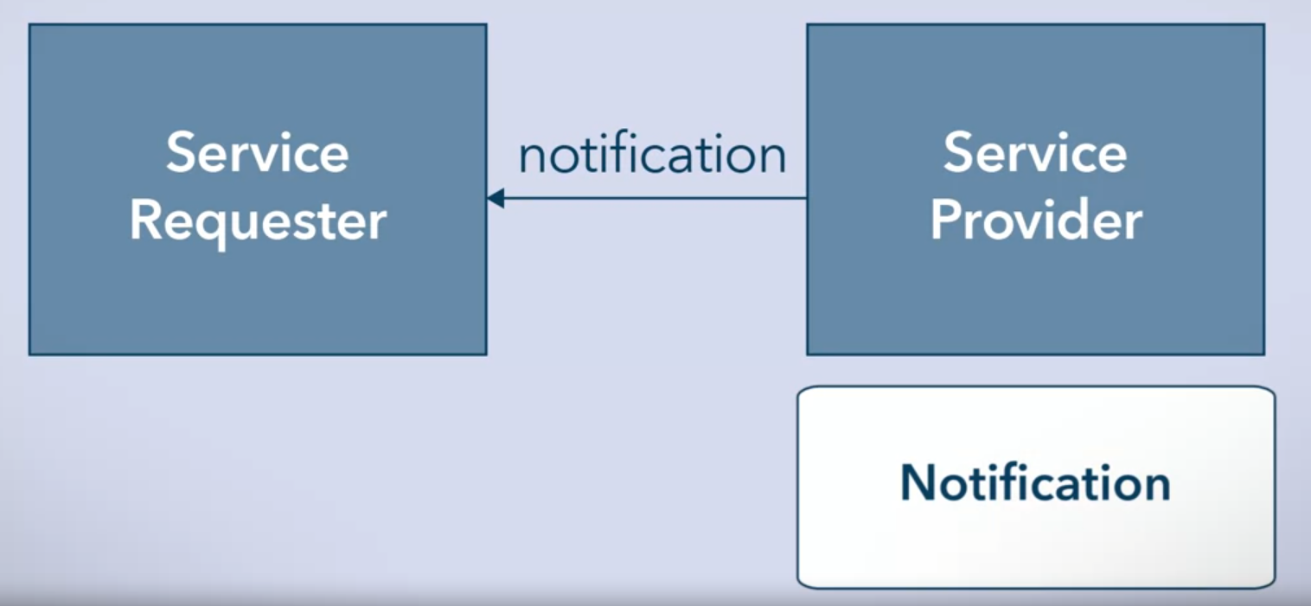

* + Asynchronous
  + Notifications

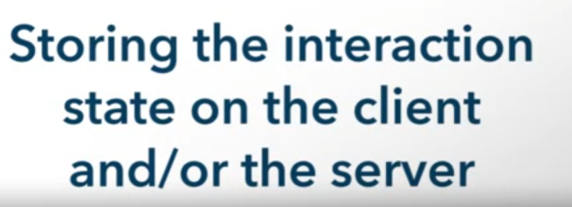

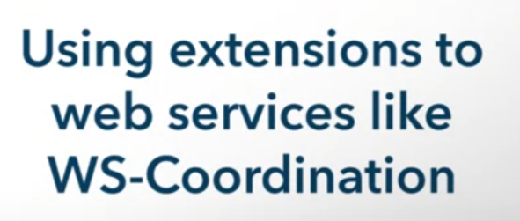

SOAP is now being superseded by:

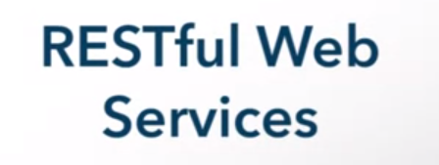

Because:

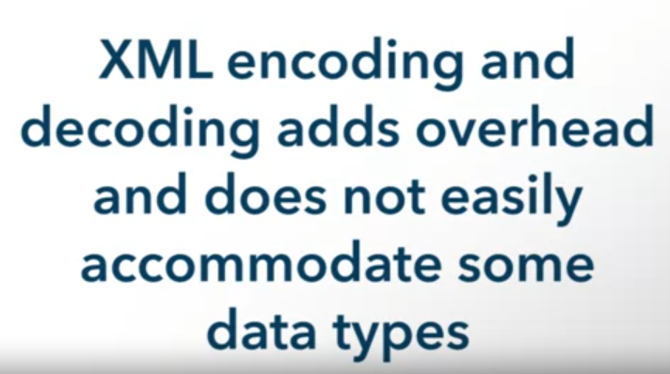

* Nevertheless SOAP had become the basis for REST and others